Atitt 漏洞scan soft

# 2019年黑客常用的漏洞扫描工具

将介绍市场上可用的十大优秀漏洞扫描工具。

**2020年10种最佳漏洞扫描工具**

1. **OpenVAS漏洞扫描工具 notfree**

**8. Wireshark**

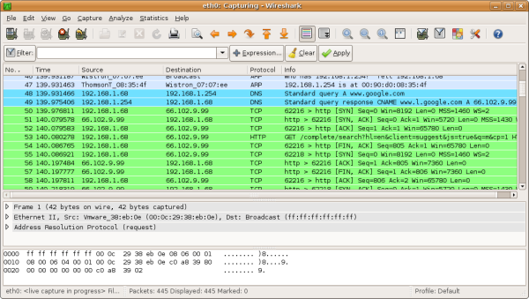

Wireshark被认为是市场上功能强大的网络协议分析器之一。

许多政府机构，企业，医疗保健和其他行业都使用它来分析非常敏感的网络。一旦Wireshark识别出威胁，便将其脱机以进行检查。

Wireshark可在Linux，macOS和Windows设备上成功运行。

Wireshark的其他亮点还包括标准的三窗格数据包浏览器，可以使用GUI浏览网络数据，强大的显示过滤器，VoIP分析，对Kerberos，WEP，SSL / TLS等协议的解密支持。

****Here is our list of the best alternatives to Microsoft Baseline Security Analyzer:****

1. **[SolarWinds Network Security Tools with Engineer’s Toolset](https://www.comparitech.com/go/solarwinds-engineers-toolset-learn-more/l/list_dd_d__post__102163/d/102163/d/102163/" \t "https://www.comparitech.com/net-admin/alternatives-to-microsoft-baseline-security-analyzer/_blank)[EDITOR’S CHOICE](https://www.comparitech.com/go/prtg-learn-more-alternatives-to-microsoft-baseline-security-analyzer/l/list_dd_d__post__102163/" \t "https://www.comparitech.com/net-admin/alternatives-to-microsoft-baseline-security-analyzer/_blank)** The SolarWinds Engineer’s Toolset includes a Security Event Manager, a Patch Manager, and a User Device Tracker to help you to tighten system security.
2. **[ManageEngine Vulnerability Manager Plus (FREE TRIAL)](https://www.comparitech.com/go/manageengine-mbsa-alternatives-alternatives-to-microsoft-baseline-security-analyzer/l/list_dd_d__post__102163/" \t "https://www.comparitech.com/net-admin/alternatives-to-microsoft-baseline-security-analyzer/_blank)** A vulnerability scanner bundled together with a patch manager and system hardening guides. Runs on Windows and Windows Server.
3. **[ManageEngine Vulnerability Manager Plus (FREE TRIAL)](https://www.comparitech.com/go/manageengine-mbsa-alternatives-alternatives-to-microsoft-baseline-security-analyzer/l/list_dd_d__post__102163/" \t "https://www.comparitech.com/net-admin/alternatives-to-microsoft-baseline-security-analyzer/_blank)** A vulnerability scanner bundled together with a patch manager and system hardening guides. Runs on Windows and Windows Server.
4. **[Paessler PRTG Network Monitor](https://www.comparitech.com/go/prtg-learn-more-alternatives-to-microsoft-baseline-security-analyzer/l/list_dd_d__post__102163/" \t "https://www.comparitech.com/net-admin/alternatives-to-microsoft-baseline-security-analyzer/_blank)**A bundle of network, server, and application monitoring tools that includes system security scanning features. Detect intruders and spot vulnerabilities with real-time system scanning.